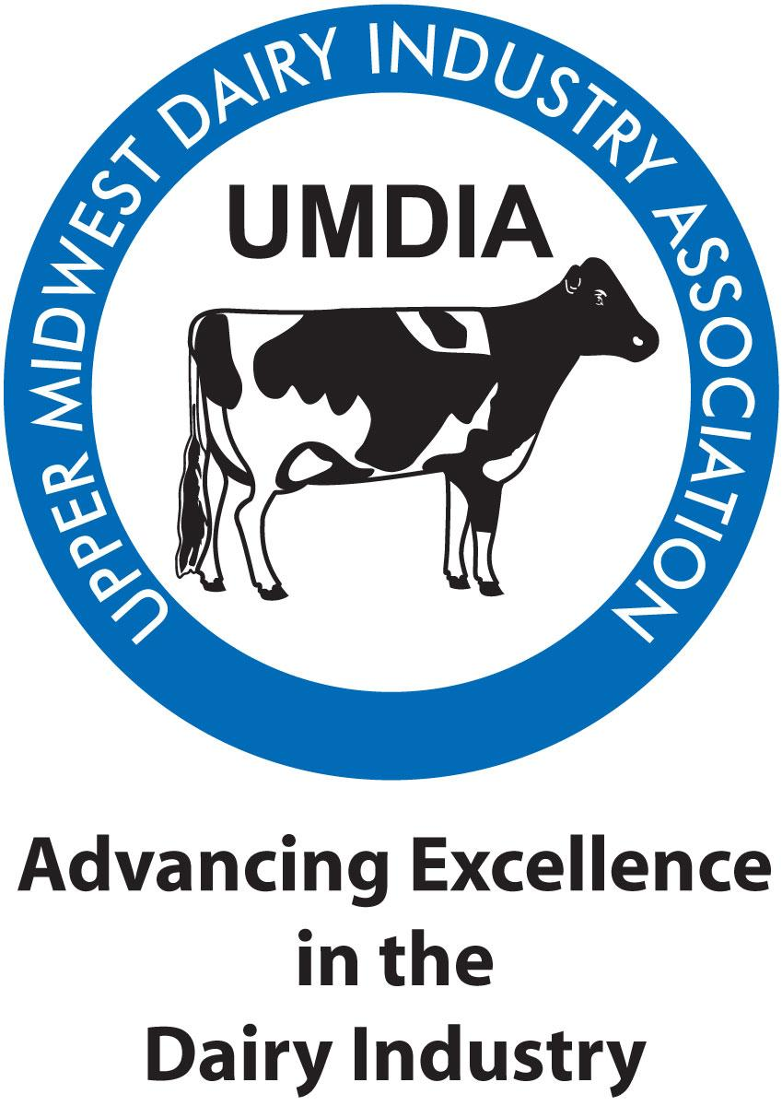

Upper Midwest Dairy Industry Association
Gene Watnaas Scholarships
The Upper Midwest Dairy Industry Association
is a non-profit group whose purpose is to promote the
dairy industry by providing information, educational services, networks and contests that encourage improvement in the quality and safety of dairy and food products.

In an effort to recognize individuals pursuing post-secondary education in a field that will enhance the quality and safety of dairy and food products, UMDIA will be awarding at least two $1,000 scholarships in 2023 to qualified applicants.

Minimum eligibility for UMDIA Scholarship Applications:
o Pursuing a degree in Animal Science with emphasis in dairy, Dairy Science, Food Animal Veterinary Medicine, Dairy Manufacturing, Dairy Technology or Dairy Food Science. (Other degree programs may be considered if there is strong evidence of commitment and contribution to the dairy industry.)
o Applications from freshmen and sophomore students will only be considered in the absence of qualifying junior or senior applicants.
o Completed at least one semester with a minimum cumulative GPA of 3.0
o Plans to complete their degree program
o Reference letter (from a faculty member or dairy industry leader, not a family member)

The application deadline is February 10, 2023.

Completed scholarship application form and letter of reference should be submitted electronically to: UMDIA Scholarship Committee at umdiamanager@gmail.com.

Please rename the files with your first and last name as the file name.
Please limit your application to two pages not including your letter of reference. Do not include this information page in your application. You may recreate the form if you desire.

Upper Midwest Dairy Industry Association
2023 SCHOLARSHIP APPLICATION FORM
(fillable form, please save as using your first and last name)

Return to: umdiamanager@gmail.com Due by: February 10, 2023
Please limit your application to two pages not including your letter of reference. You may recreate this form if you desire.

Name:
Address: City: State: Zip:
County Phone E-mail address:
High School Year of Graduation
Address: City: State: Zip:
Phone: Cumulative Grade Point Average
College: Phone:
Address: City: State: Zip:
Year/Semester: Current Grade Point Average:
Major
Minor
1. Explain your reasons for choosing dairy as your field of study at this college.

2. Describe any work experience that you have in the dairy industry.

3. Describe your involvement in school and/or community organizations. Please list dates, offices held, awards received, etc.

4. Explain your future plans and career goals, including the contributions you hope to make in the dairy industry. How will you participate in/give back to UMDIA?

